Gantt Chart
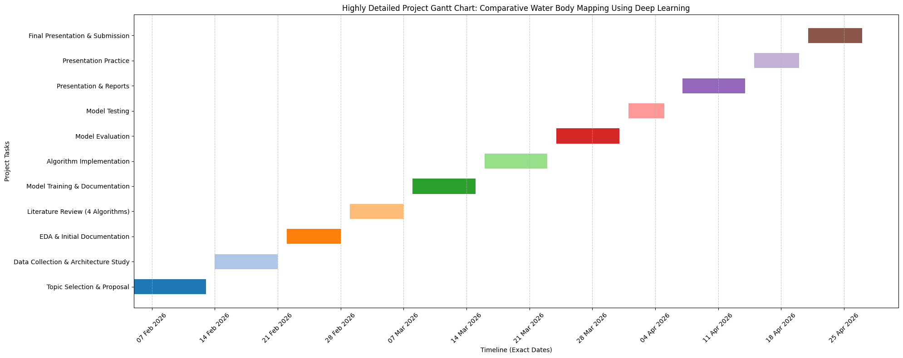

Studied the workflow of data science projects .
- Problem Definition
- Data Collection and Loading (loading CSV, database, etc.)
- Data Pre Processing
- EDA (Exploratory Data Analysis)
- Feature Selection and Engineering
- Data Splitting (Train-Test Split)
- Model Selection & Training
- Hyperparameter Tuning
- Evaluation Metrics

